**Experiment No. 4**

|  |  |
| --- | --- |
| **Title: Design a 4 bit binary to BCD convertor using the**  **Circuitverse simulator.** |  |

**Batch: A3 Roll No.: 16010421074 Experiment No.: 4**

|  |  |
| --- | --- |
| **Aim:** Design a 4 bit binary to BCD convertor using the Circuitverse simulator. |  |

**_______________________________________________________________ ___ _**

**Resources needed:** Circuitverse online simulator

**Theory:**

* Although the CPU uses binary arithmetic for computation, the result has to be converted into decimal for display purpose. The token counter displays, railway platform displays, even calculator displays are all decimal displays. Conversion from binary to decimal is a non-trivial process. To reduce the processing overhead, BCD format offers a nice alternative.
* In BCD (Binary Coded Decimal) format the decimal digits are stored as separate binary numbers. When these numbers are incremented, decremented or reset, only part of the remaining number needs to be changed. Also, the conversion from binary to decimal and unpacking of the digits is avoided.
* Because the BCD numbers are essentially decimal numbers, only 0-9 digits are used. Therefore when we do binary to BCD mapping, we either wrap around the numbers from 10 to 15 or we treat them as don’t cares.

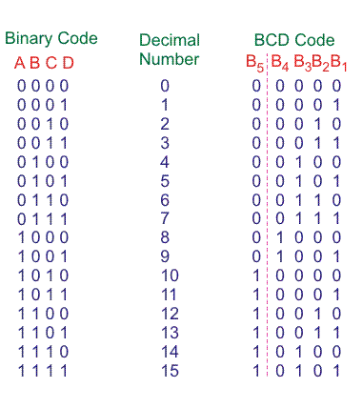**__________________________________________________________________________**

**Procedure**:

1. Design logic circuit for the binary to BCD convertor using the following steps:-
2. Draw the truth table for the 4 bit convertor (already given above)
3. Draw the K map for each of the (four) outputs
4. Calculate the logic equation for each output
5. Draw the circuit on paper
6. Verify the circuit using the Circuitverse simulator. (Lab instructor will guide you on how to create an account use the simulator).
7. Upload the write-up with the solved design problems given in write-up.

**___________________________________________________________________________**

**Observations and Results:**

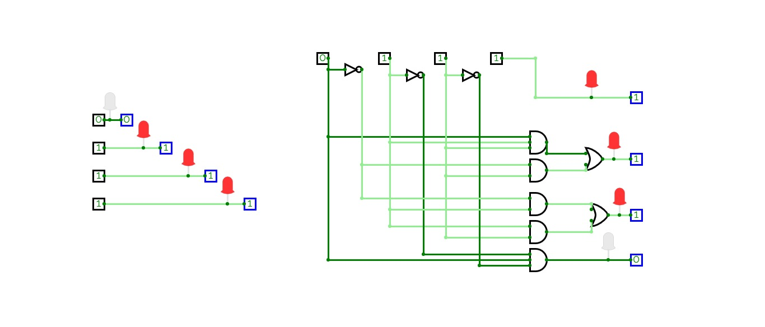

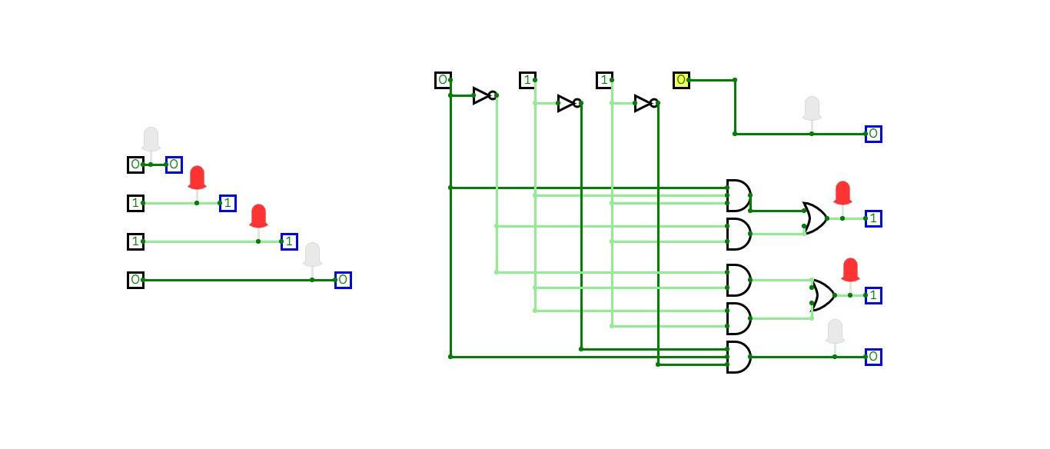

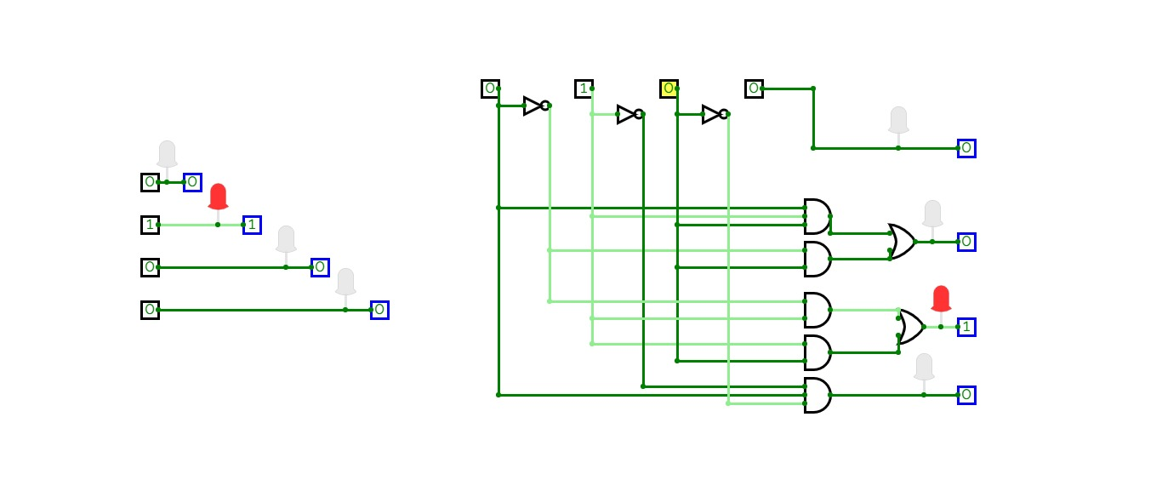

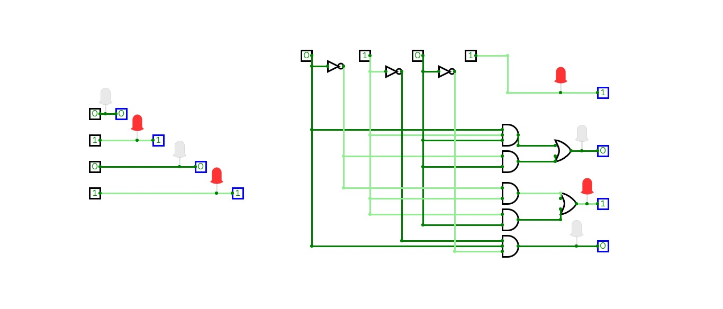

**___________________________________________________________________________**

**Outcomes:**

**CO2:** Understanding the basic building blocks, techniques used in digital logic design.

**CO3:** Design the combinational and sequential circuits using basic building blocks.

**___________________________________________________________________________**

**Conclusion:** Hence we learnt how to design a 4 bit binary to BCD convertor using the Circuitverse simulator.

**Grade: AA / AB / BB / BC / CC / CD /DD**

**Signature of faculty in-charge with date**

**___________________________________________________________________________**

**References:**

**Books/ Journals/ Websites:**

1. R. P. Jain, “Modern Digital Electronics”, Tata McGraw Hill.